FAS 4475 Group 5 Part C
Alexandra Schol, Rachel Sollers, Marquita Taylor, and Anjelika Tremblay
Professor Filerino
FAS 4475
Berkeley College

FAS 4475 Group 5 Part C
Product Spec Sheet and Content
STYLE SPECIFICATION SHEET

Front
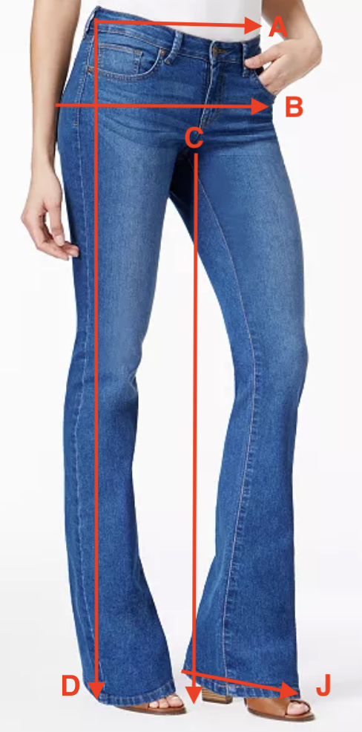

Style #: _WBC-111___ Design #: __HRGLS-111_____
Season: __Fall 2019___ Date: __1 Mar 2019________
Description: West Boot Cut Jean Color: True Blue Wash

Fabric #: __DM-001________________________
Type/Fiber content: ___96% cotton, 4% Lycra_____
Finish: __True Blue Wash- piece dyed________________
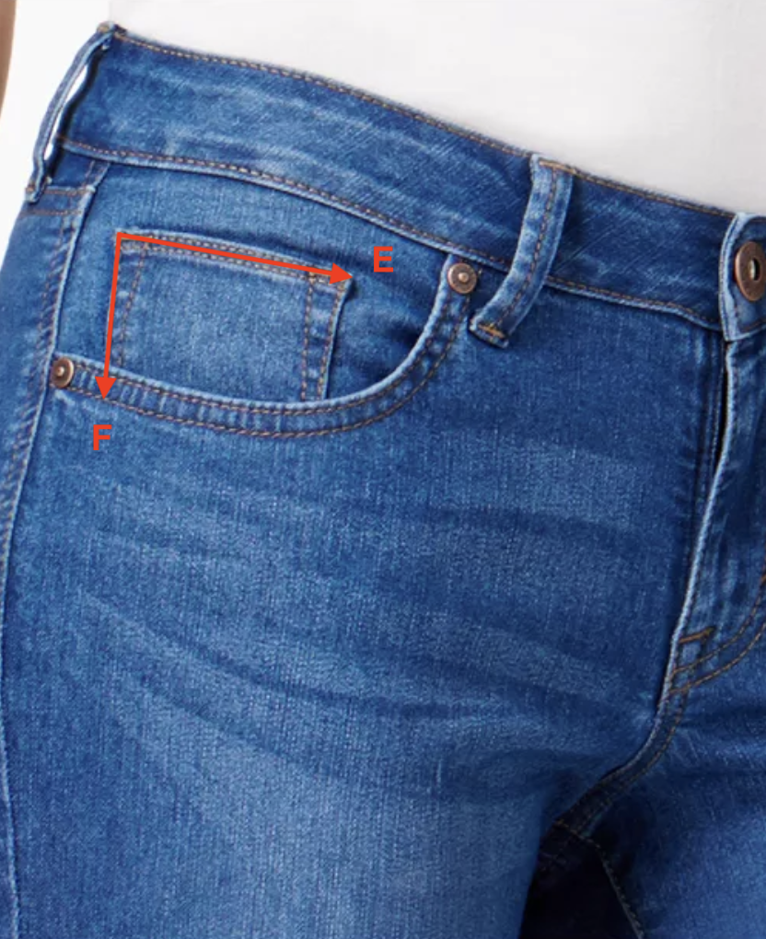
Size:  Line | 24 | 25 | 26 | 27 | 28 | 29 | 30 | 31 | 32
A | 24” | 25” | 26” | 27” | 28” | 29” | 30” | 31” | 32”
B | 32”  33”  34” | 33.5  34.5  35.5 | 34.5  35.5  36.5 | 36  37  38 | 37  38  39 | 38.5  39.5  40.5 | 40  41  42 | 41  42  43 | 42.5  43.5  44.5
C | 32” | 32” | 32” | 32” | 32” | 32” | 32” | 32” | 32”
D | 40” | 40” | 40” | 40” | 40” | 40” | 40” | 40” | 40”
E | 2.5” | 2.5” | 2.5” | 2.5” | 2.5” | 2.5” | 2.5” | 2.5” | 2.5”
F | 2.5” | 2.5” | 2.5” | 2.5” | 2.5” | 2.5” | 2.5” | 2.5” | 2.5”
G | 5” | 5” | 5” | 5.5” | 5.5” | 5.5” | 6” | 6” | 6”
H | 5” | 5” | 5” | 5.5” | 5.5” | 5.5” | 6” | 6” | 6”
I | 2” | 2” | 2” | 2.25” | 2.25” | 2.25” | 2.5” | 2.5” | 2.5”
J | 19” | 19” | 19” | 20” | 20” | 20” | 21” | 21” | 21”

Back
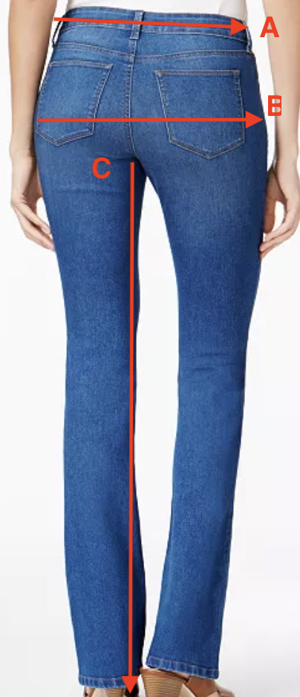
Findings/Trim
 | Type/Number | Color | Size | Amount
Thread | Singer 67120 | Old Gold | Heavy Duty | 300 meters
Rivets | RV9295D | Antique Brass | 9.2mm | 4
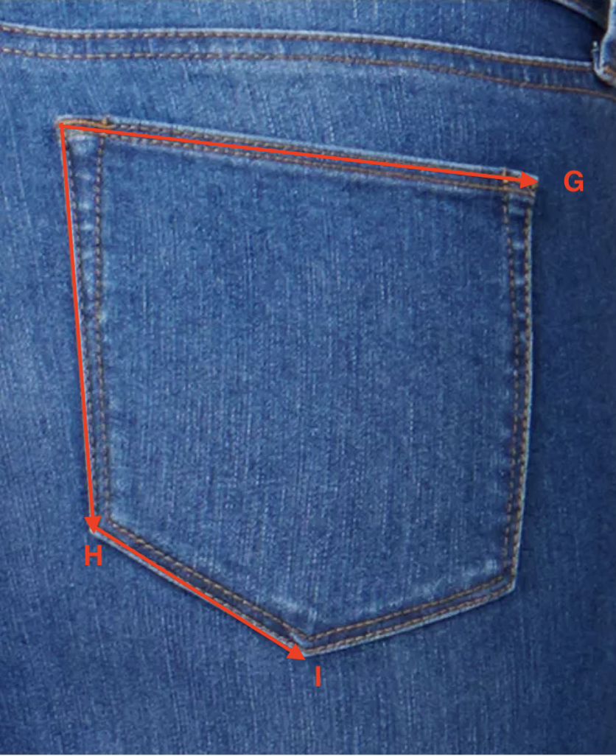
Hangtag: | Label:
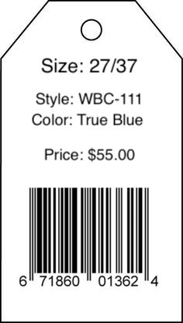 | 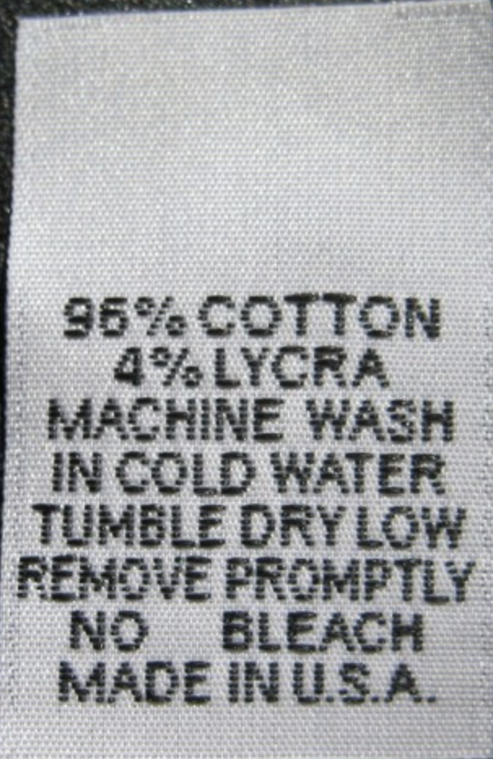

STYLE SPECIFICATION SHEET

Front
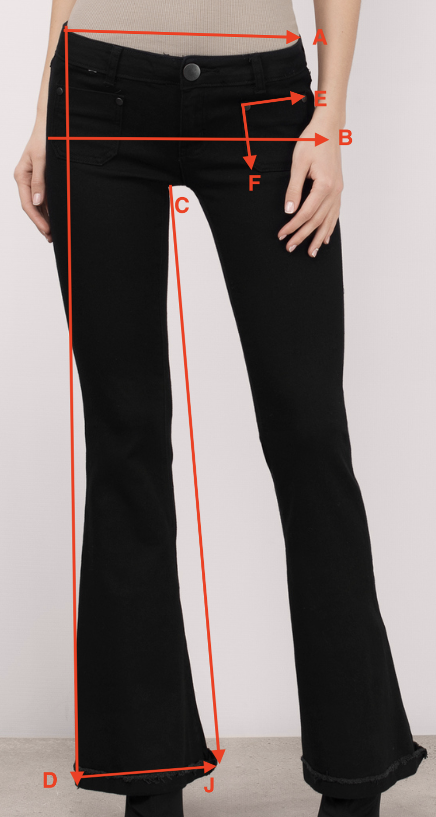

Style #: _DEL-113___ Design #: __HRGLS-122_____
Season: __Fall 2019___ Date: __1 Mar 2019________
Description: Delilah Flare Jean Color: Asphalt

Fabric #: __DM-001________________________
Type/Fiber content: ___96% cotton, 4% Lycra_____
Finish: __Asphalt Wash – piece dyed________________

Size:  Line | 24 | 25 | 26 | 27 | 28 | 29 | 30 | 31 | 32
A | 24” | 25” | 26” | 27” | 28” | 29” | 30” | 31” | 32”
B | 32”  33”  34” | 33.5  34.5  35.5 | 34.5  35.5  36.5 | 36  37  38 | 37  38  39 | 38.5  39.5  40.5 | 40  41  42 | 41  42  43 | 42.5  43.5  44.5
C | 32” | 32” | 32” | 32” | 32” | 32” | 32” | 32” | 32”
D | 40” | 40” | 40” | 40” | 40” | 40” | 40” | 40” | 40”
E | 3” | 3” | 3” | 3.5” | 3.5” | 3.5” | 4” | 4” | 4”
F | 4” | 4” | 4” | 4.5” | 4.5” | 4.5” | 5” | 5” | 5”
G | 5” | 5” | 5” | 5.5” | 5.5” | 5.5” | 6” | 6” | 6”
H | 5” | 5” | 5” | 5.5” | 5.5” | 5.5” | 6” | 6” | 6”
I | 2” | 2” | 2” | 2.25” | 2.25” | 2.25” | 2.5” | 2.5” | 2.5”
J | 21” | 21” | 21” | 22” | 22” | 22” | 23” | 23” | 23”

Back
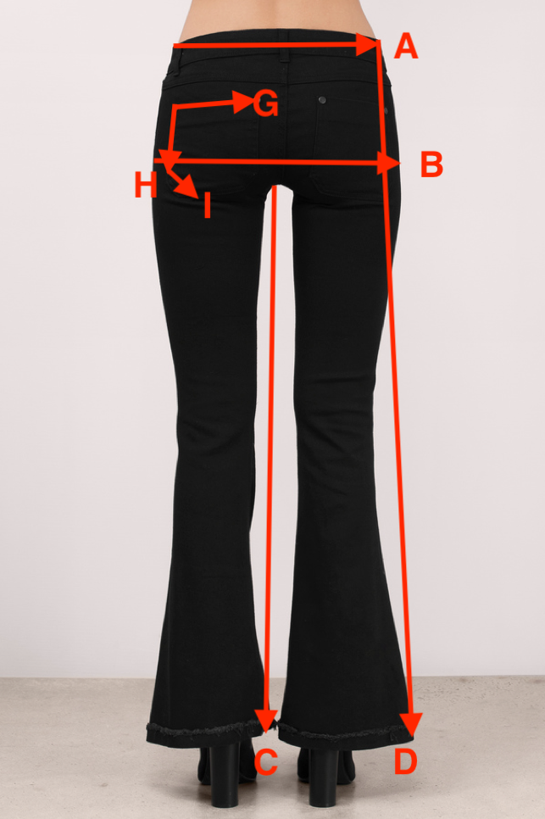
Findings/Trim
 | Type/Number | Color | Size | Amount
Thread | Gutterman000 | Black | Extra Heavy | 300 meters
Rivets | 1373-13 | Black | 9.2mm | 8

Hangtag: | Label:
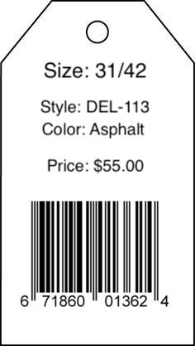

STYLE SPECIFICATION SHEET

Front
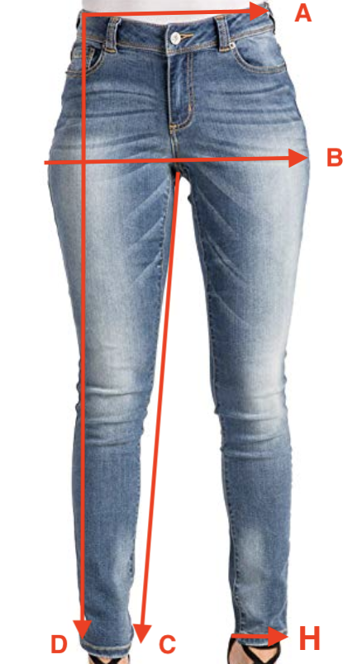

Style #: _JES-112___ Design #: __HRGLS-131_____
Season: __Fall 2019___ Date: __1 Mar 2019________
Description: Jessie Skinny Jean Color: Vintage Blue

Fabric #: __DM-001________________________
Type/Fiber content: ___96% cotton, 4% Lycra_____
Finish: __Vintage Wash – piece dyed________________

Size:  Line | 24 | 25 | 26 | 27 | 28 | 29 | 30 | 31 | 32
A | 24” | 25” | 26” | 27” | 28” | 29” | 30” | 31” | 32”
B | 32”  33”  34” | 33.5  34.5  35.5 | 34.5  35.5  36.5 | 36  37  38 | 37  38  39 | 38.5  39.5  40.5 | 40  41  42 | 41  42  43 | 42.5  43.5  44.5
C | 32” | 32” | 32” | 32” | 32” | 32” | 32” | 32” | 32”
D | 40” | 40” | 40” | 40” | 40” | 40” | 40” | 40” | 40”
E | 5” | 5” | 5” | 5.5” | 5.5” | 5.5” | 6” | 6” | 6”
F | 5” | 5” | 5” | 5.5” | 5.5” | 5.5” | 6” | 6” | 6”
G | 2” | 2” | 2” | 2.25” | 2.25” | 2.25” | 2.5” | 2.5” | 2.5”
H | 10” | 10” | 11” | 11” | 12” | 12” | 13” | 13” | 13”

Back
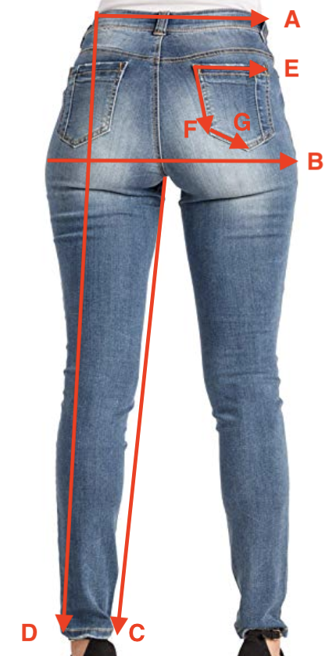
Findings/Trim
 | Type/Number | Color | Size | Amount
Thread | Singer 67120 | Old Gold | Heavy Duty | 300 meters
Rivets | RV9295D | Antique Brass | 9.2mm | 4
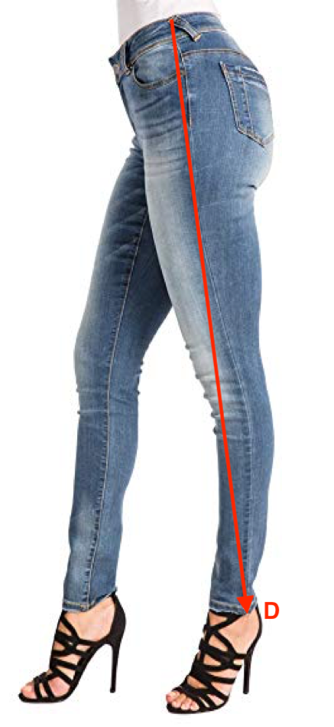
Hangtag: | Label:
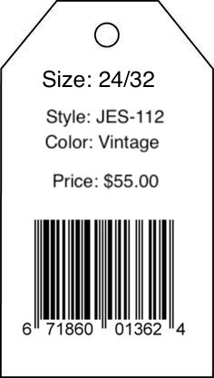

Cost Sheet
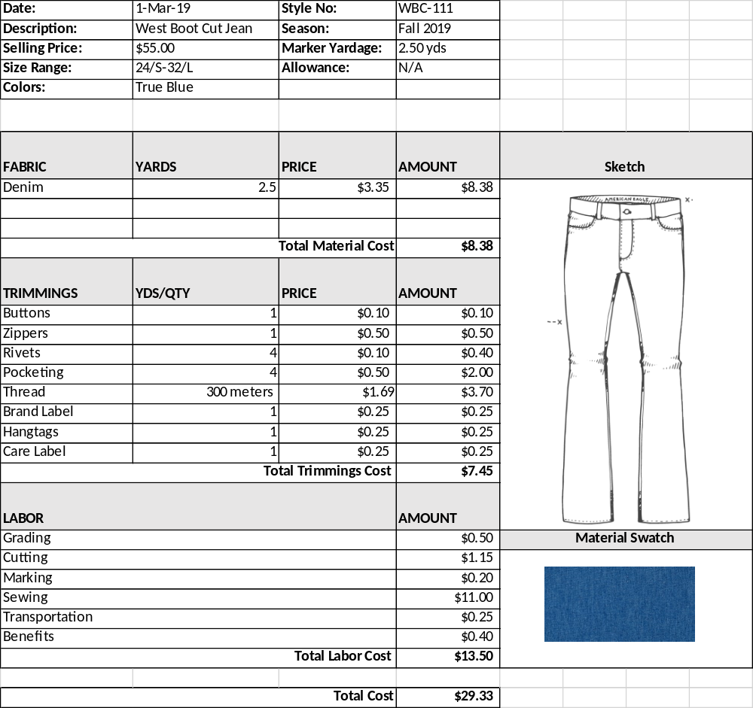

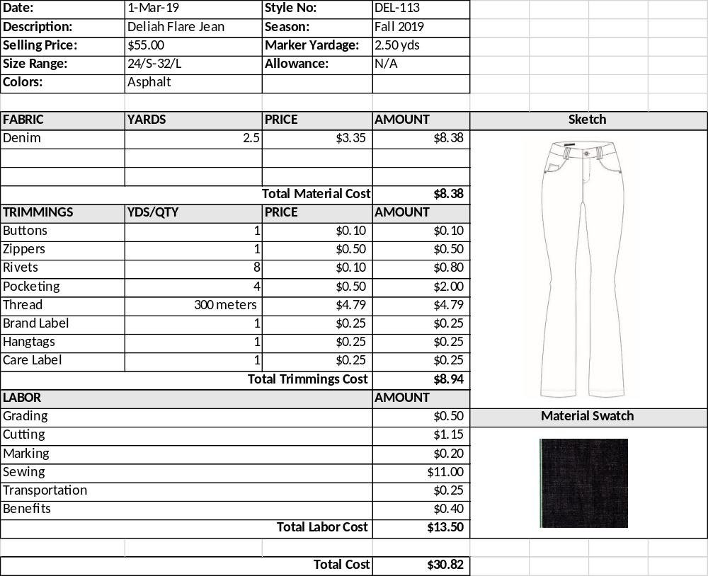

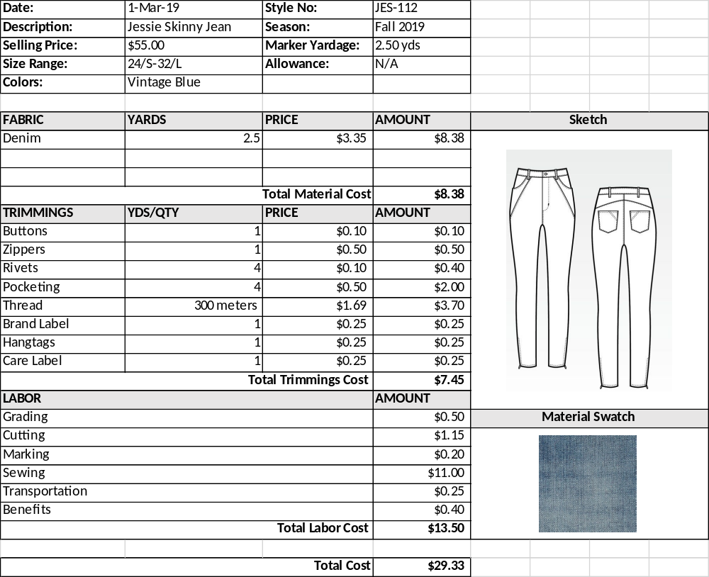

References
000 Black 100m Gutermann Extra Strong Thread [Digital image]. (n.d.). Retrieved from https://www.moodfabrics.com/000-black-100m-gutermann-extra-strong-thread-100739?utm_source=google_shopping&gclid=CjwKCAiAkrTjBRAoEiwAXpf9CSZyB07UXBend9hZ5-7D8UXEtwCxvU1iqEnsu0635eFW8AMPXqRqIRoCSCgQAvD_BwE
Boot Cut Jean [Digital image]. (n.d.). Retrieved from https://americaneagleoutfitters.files.wordpress.com/2013/07/jeansketch_kick-boot1.png
Double Cap Rivets Black Plated Medium 100 Pack 1373-13 by Stecksstore [Digital image]. (n.d.). Retrieved from https://www.ebay.com/p/Double-Cap-Rivets-Black-Plated-Medium-100-Pack-1373-13-by-Stecksstore/1637305159?iid=191295908503&chn=ps
Flare Jeans [Digital image]. (n.d.). Retrieved from https://static1.squarespace.com/static/56d4851737013b227d588fc3/56de5f5cf8baf326128629b9/56de69f559827ed85c21ca16/1457418385277/Jeans template Boot small.jpg?format=1000w
Kaufman Selvedge Denim Green/Grey Fabric [Digital image]. (n.d.). Retrieved from https://images.fabric.com/images/693/693/0429512.jpg
Light Blue Denim Swatch [Digital image]. (n.d.). Retrieved from https://bonobos-prod-s3.imgix.net/products/55336/original/Denim_Selvidge-Denim_20414-BLX60_swatch.jpg?1517267614=
RV9295 Double Cap Rivet, Cap 9.2mm, Post 9.5mm, Antique Brass, Solid Brass (100 per bag) [Digital image]. (n.d.). Retrieved from https://www.buckleguy.com/rv9295-double-cap-rivet-cap-9-2mm-post-9-5mm-antique-brass-solid-brass-100-per-bag/?gclid=CjwKCAiAkrTjBRAoEiwAXpf9CazAc_rIKsYBYO1UTBjN34O_T55-8QQt0sQJp_a1_JDrTdrYwAUP4BoCpxAQAvD_BwE
Singer 100 yds Heavy Duty Denim Jean Thread -Old Gold [Digital image]. (n.d.). Retrieved from https://www.joann.com/heavy-duty-denim-jean-thread-150-yards-old-gold/1078526.html
Skinny Jeans [Digital image]. (n.d.). Retrieved from https://i.pinimg.com/736x/34/a0/01/34a0019054b2cdab335bb4f249b222e6--high-waist-jeans-stretch-jeans.jpg
Telio 4.8 oz Denim Chambray Light Blue [Digital image]. (n.d.). Retrieved from https://images.fabric.com/images/200/200/0455502.jpg

